Issues/Bugs Fixed:

- Forex gain/loss is posting in accounting enquiry with credit on both entries.
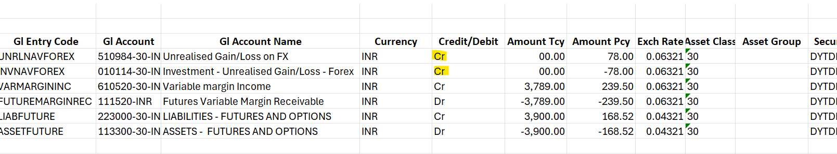

Fix: Negative Amount Pcy corrected to Debit.

- In Purchase Sale report, Security code and Security Name has spacing issue. Due to this unable to search particular security from the report.
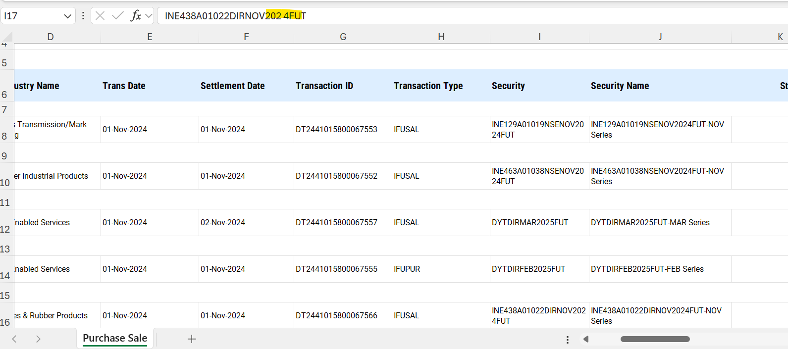

Fix: Spacing has been removed.

- In Holding Statement report, Security and Security Name has spacing issue. Due to this unable to search particular security from the report.
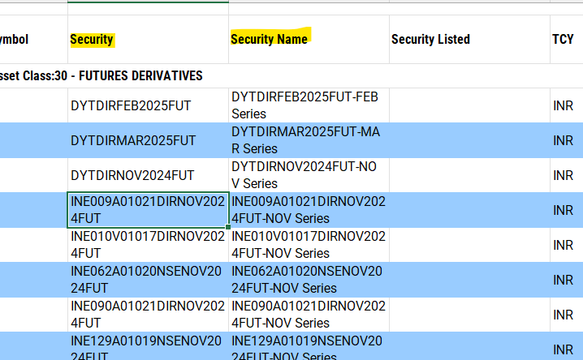

Fix: Spacing has been removed.
- Exchange Rate not displaying in accounting enquiry while viewing in the screen level.
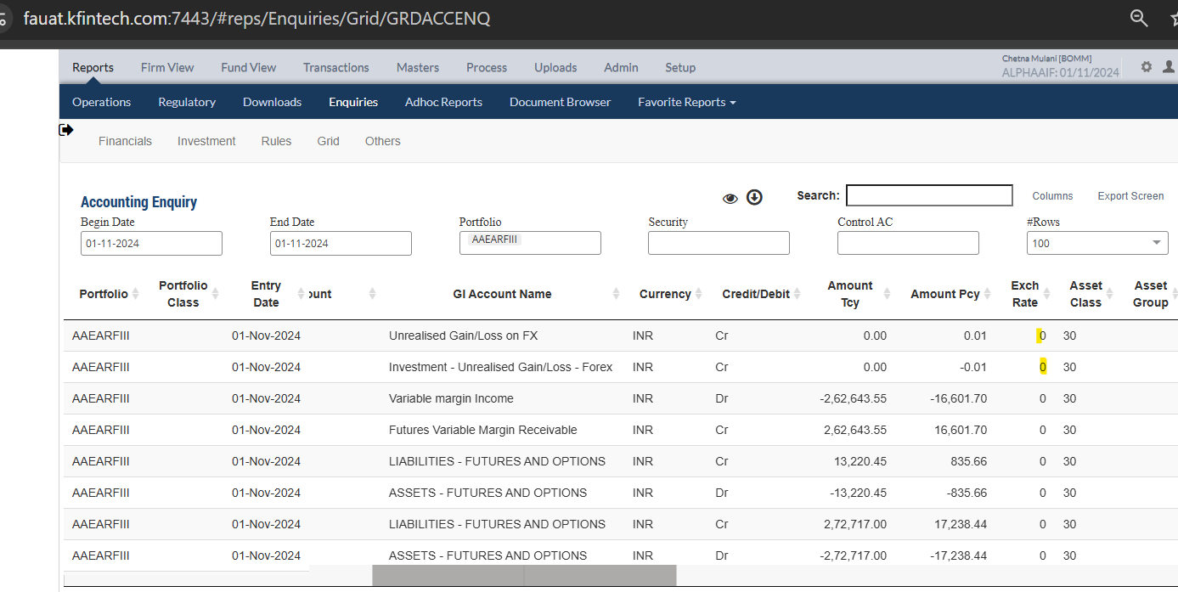

Fix: Exchange Rate is displaying in grid level.

